Equipment needed for Projects

For carrying out your project work you need to borrow the following equipment:

• Level  • Tripod  • Staff (4 metre) | • Staff bubble  • Measuring tape (30 metre)  • Wooden pegs (if needed)

Additional equipment is needed for some other projects and the lecturer will inform you what you need to do this exercises.

The following information is extracted from 'LEICA NA720 User Manual'.

Level types

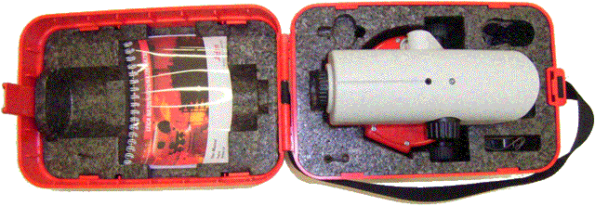
There are different types (Leica, Sokkia, Wild) of levels you can borrow. The level opposite is a Leica NA720. Most level instruments have an automatic horizontal adjustment of the line of sight. Levels are supplied in a case in which the instrument can be shock proof stored. All survey levels operate in a similar way. The function and operation of levels is explained using the Leica 720 which is the most available instrument in the storerooms.
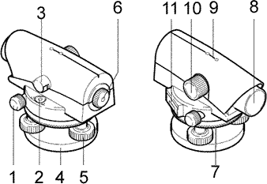 |  | - Endless drive (both sides)  - Bubble level (to check horizontal plane)  - Mirror to view bubble level  - Base plate (sits on tripod)  - Footscrew (to adjust the horizontal plane)  - Eyepiece (focus adjustment & cross-hair)  - Knurled ring (for horizontal circle reading)  - Objective  - Course aiming devise  - Focusing knob (turn until staff reading is clearly visible)  - Window for digital angle reading (see 7)

Setting up the tripod

• 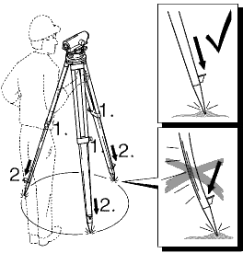 |  | - Loosen screws of tripod legs, pull out to required length and tighten screws.  - In order to guarantee a firm foothold sufficiently press the tripod legs into the ground. When pressing the legs into the ground note that the force must be applied along the legs.  - Check all screws and bolts for correct fit.  When setting up the tripod pay attention to a horizontal position of the tripod plate. Minor inclinations of the tripod can be corrected with the footscrews of the tribrach.
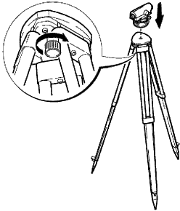 |  | - Place level onto tripod head. Tighten central fixing screw of tripod.  - Turn footscrews A and B simultaneously in opposite directions until bubble is in the centre (on the imaginary "T").  - Turn the instrument 90° and then turn the foot screw C until bubble is centred.  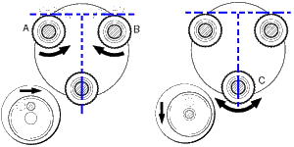
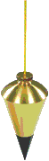
If you want to centre an instrument over a ground point:

1. Attach plumb bob and arrange the tripod in such way that the plummet is over the point.
2. For fine adjustment loosen central fixing screw slightly and shift instrument parallel on tripod until the plummet is exactly over the point.
3. Tighten central fixing screw.

Focusing telescope

- Aim telescope against a bright background (e.g. white paper).
- Turn eyepiece until reticule is sharp-focused and deep black. Now the eyepiece is adapted to your eye.
- Aim telescope on staff using the coarse aiming device.
- Turn focusing knob until image of staff is sharply focused.
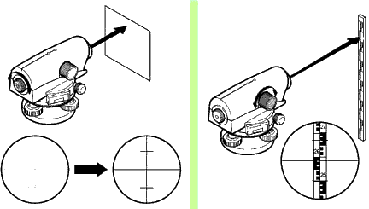

Levelling staffs (rods) and accessories
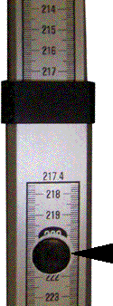
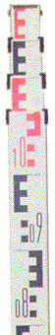
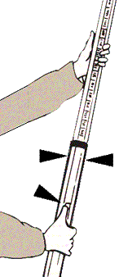
There are many types of staffs, with names that identify the form of the graduations and other characteristics. Staffs can be one piece, but most of them are sectional and adjust the length by telescoping..
The metric staff has major numbered graduations in meters and tenths of meters (there is a tiny decimal point between the numbers). Our staves have an ''E'' shape mark (or its mirror image) with horizontal spaces between them of 10 mm.
When viewed through an instrument's telescope, the observer can easily visually interpolate a 10 mm mark to a quarter of its height, giving a reading accuracy of 2.5 mm. On one side of the rod, the colours of the markings alternate between red and black with each meter of length.
The Black arrows indicate where to push to extend the staff to its full length.
Staff readings

The figure below shows three different staff readings:

It is easy to read (b) and (c) because the cross-hair is exactly on a mark division. The reading for (a) is between 1.630 and 1.640. To assess the mm reading you have to estimate where the position of the cross-hair is. For (a) the reading is 1.636. The millimeter reading is to be estimated and can very between ± 1 mm.

reading (a) is 1.636 (b) is exactly 1.500 and (c) is 1.580

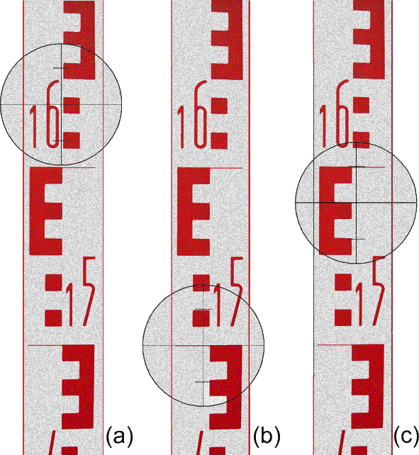

Please note: All staff readings must be indicated in millimetre or meter with three digitals (decimetre, centimetre & millimetre.

